**Capstone Project- The Battle of the Neighborhoods**

**A. Introduction:**

**A.1. Background**

**Toronto** is the provincial capital of Ontario and the most populous city in Canada, with a population of 2,731,571 in 2016. Current to 2016, the Toronto census metropolitan area (CMA), of which the majority is within the Greater Toronto Area (GTA), held a population of 5,928,040, making it Canada's most populous CMA. The city is the anchor of the Golden Horseshoe, an urban agglomeration of 9,245,438 people (as of 2016) surrounding the western end of Lake Ontario.

Toronto is an international center of business, finance, arts, and culture, and is recognized as one of the most multicultural and cosmopolitan cities in the world.

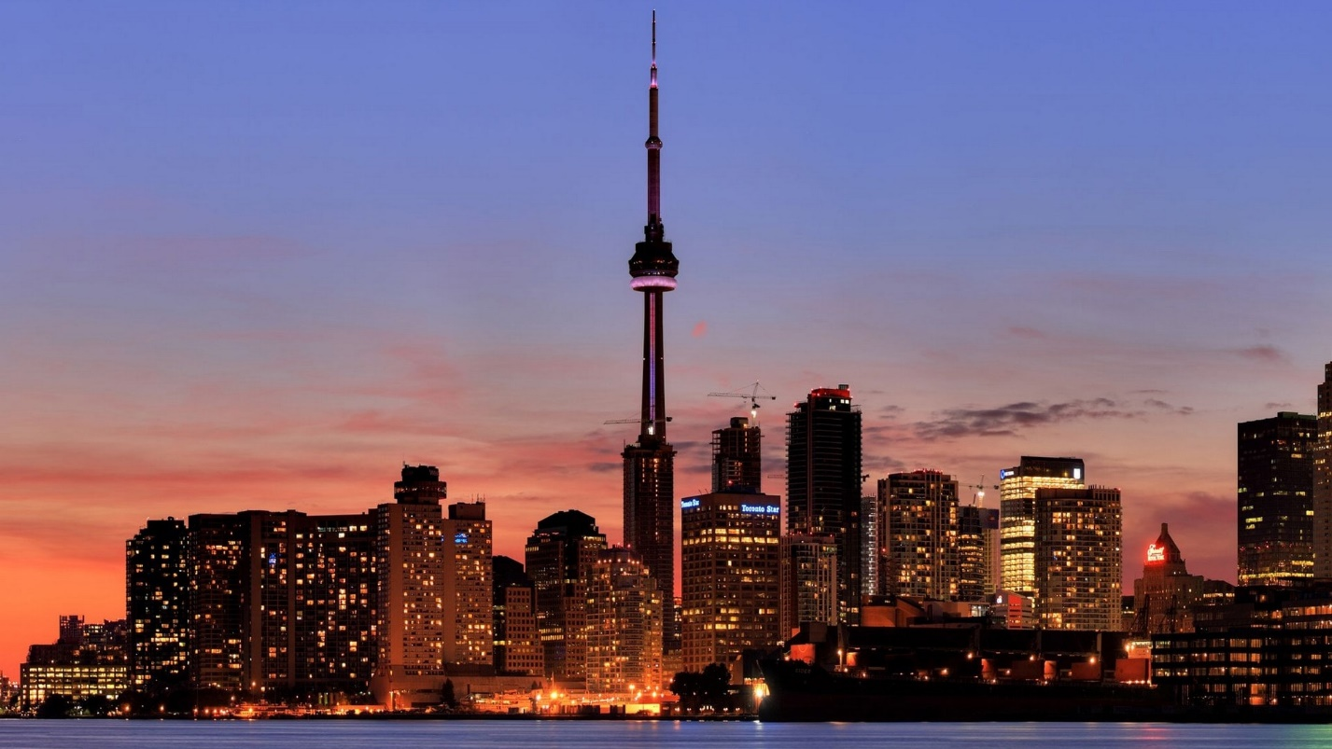

**Brief history about Toronto**: People have travelled through and inhabited the Toronto area, located on a broad sloping plateau interspersed with rivers, deep ravines, and urban forest, for more than 10,000 years. After the broadly disputed Toronto Purchase, when the Mississauga surrendered the area to the British Crown, the British established the town of **York** in 1793 and later designated it as the capital of Upper Canada. During the War of 1812, the town was the site of the Battle of York and suffered heavy damage by United States troops. **York** was renamed and incorporated in 1834, as the city of **Toronto**. It was designated as the capital of the province of Ontario in 1867 during Canadian Confederation.

**A.2. Problem Description**:

Now let me explain the context of this Capstone project through a scenario. Say you live on the west side of the city of Toronto in Canada. You love your neighborhood, mainly because of all the great amenities and other types of venues that exist in the neighborhood, such as gourmet fast food joints, pharmacies, parks, graduate schools and so on. Now say you receive a job offer from a great company on the other side of the city with great career prospects. However, given the far distance from your current place you unfortunately must move if you decide to accept the offer.

Wouldn't it be great if you are able to determine neighborhoods on the other side of the city that are the same as your current neighborhood, and if not perhaps similar neighborhoods that are at least closer to your new job?

**A.3. Objective**

The aim of this report is to study and analyze the neighborhoods of Toronto city and group them into similar clusters and, to analyze those clusters to gather meaningful information. That information can be used to find out neighborhoods that are same as your current neighborhood or at least similar.

**A.4. Target Audience**

This information provided by this report would be useful for people who are interested in relocating to a different part of the city and are interested in finding new neighborhoods that are highly similar to their existing neighborhood.

**B. Data Description:**

To consider the objective stated above, we can list the below data sources used for the analysis.

**a) Toronto Neighborhood Data**: The following Wikipedia page was scraped to pull out the necessary information: <https://en.wikipedia.org/wiki/List_of_postal_codes_of_Canada:_M>

The information obtained i.e. the table of postal codes was transformed into a pandas dataframe for further analysis.

**b) Coordinate data for each Neighborhood in Toronto**: The following csv file gave us the geographical coordinates of each postal code: <http://cocl.us/Geospatial_data>